МРНТИ 55.49.29,
УДК 629.78

Probe diagnostics and optical emission spectroscopy of the plasma plume created by a magnetic nozzle of an inductively coupled plasma source

A R Gizzatullin¹, A I Shumeiko², V D Telekh¹

Kazan State Power Engineering University, Krasnoselskaya street, 51, Kazan, 420066, Russia
Bauman Moscow State Technical University, Educational Scientific Centre
for Photon Energetics, 2nd Bauman str., 5/1, Moscow, 105005, Russia

e-mail: gizzatar@gmail.com
Abstract. The Wave Plasma Thruster is suggested to support small spacecraft on very low Earth’s orbits and to de-orbit it after fulfilling its space mission, has been tested successfully. Using a retarding field energy analyser, Langmuir probe and optical emission spectroscopy, the plasma flow formed by a magnetic nozzle have been characterized axially. The presence of the double-layer (DL) has been confirmed by a rapid change in the plasma potential along the axis. The axial electron temperature variation of the Langmuir probe measurements shows that the DL forms near a region of the maximum of magnetic field gradient when the plasma is operated in wave mode. The emission intensity of the argon atom lines 750 nm and 811 nm shows a similar spatial distribution to the electron temperature along the axis. The tests have been performed for operating conditions of 1.5 mg·s⁻¹ of Argon, 50 mPa gas pressure, 120W of radio-frequency forward power at 13.56 MHz, and a maximum axial magnetic field of 200 G.
Key words: plasma thruster, helicon thruster, probe diagnostics, spectroscopy

- Introduction
Nowadays the development of low Earth orbit (LEO) (up to 2000 km) small spacecraft (SSC) is of particular interest. Such devices are planned to be used for effective telecommunications systems, advanced Earth research, etc. Among the space missions being developed in LEO, we can highlight the main international projects for creating a swarm of a large number of SSC, such as the OneWeb Satellite Constellation and Starlink, as well as the Russian project of the Sphere satellite communication system. Their advantages include the low price of launching (altitude 160-300 km) and the increased resolution of the target equipment.
A key problem that arise in the design of the very low-orbit SSC is the presence of aerodynamic force, which decelerates it when flying in the upper atmosphere. For example, for a SSC at an altitude of 200 km with a shape factor $c_{f}=3$ and a cross-sectional area $S_{SC}=1$ m² the drag force will be 18 mN [1]. The lifetime of a passive SSC on LEO ranges from several weeks to several months and depends on many factors, especially strongly on the density of the residual atmosphere at the orbit height.
Nowadays there are several types of thrusters which are used for supporting of SSC in LEO. One of these propulsion systems is the SPD-50M of EDB «Fakel» which is used onboard OneWeb’s satellites. However, the short lifetime of the SPD-50M as the other electrostatic electric propulsion systems, such as Hall [2] and Ion thrusters, cannot increase the SSC’s lifetime and guarantee successful de-orbiting. It is mostly associated with the use of a cathode-compensator that neutralizes the outgoing accelerated ion beam. Existing cathode-compensators use lanthanum hexaboride as a thermal electron source. During operation in a medium containing oxygen molecules, atoms and ions, which present in the residual atmosphere in LEO, lanthanum hexaboride is oxidized to form lanthanum oxide, which leads to a deterioration in the performance of the cathode-compensator or to its complete failure in a short period of time.
In the last decades, a significant interest has been focused on the electrodeless methods of the plasma accelerating [3-5]. One of these methods is application of a magnetic nozzle.
Plasma flowing through magnetic nozzles has been observed in many natural systems and is used in a variety of terrestrial applications ranging from electric propulsion to plasma processing.
A magnetic nozzle, consisting of an applied convergent-divergent axysimmetric magnetic field, constitutes the main acceleration stage of several advanced plasma propulsion concepts such as the Helicon Plasma Thruster [6] and the Variable Specific Impulse Magnetoplasma Rocket (VASIMR) [7].
Similar to de Laval nozzles that convert random thermal motion into directed flow, magnetic nozzles are used to redirect the motion and momentum of the plasma flowing through the nozzle. To this end, a magnetic nozzle can be used to improve thrust efficiency and provide a means of controlling the plume geometry and plasma energy distribution functions.

- Experimental Setup
The laboratory model of the Wave Plasma Thruster (WPT) consists of a quartz glass discharge chamber, with a closed end of quartz glass, 2-mm wall thickness, 16 mm in inner diameter, and a length of 100 mm. The open end of the discharge chamber formed the collimated plasma flow.
For the present experiments, the discharge chamber is positioned in line with the vacuum chamber. The solenoids produce a divergent magnetic field with an axial maximum of 200 G at z=0 cm that decreases to a few gauss downstream [3]. A half turn helical antenna 8 cm long constructed from copper surrounds the discharge chamber and is attached to one of the vacuum chamber flange. The antenna is a few millimeters from the discharge chamber to minimize capacitive coupling and to limit thermal effects.
The WPT is installed inside a nonmagnetic stainless steel vacuum chamber 0.7 m in diameter and 1 m long. The vacuum chamber allow to simulate the vacuum conditions of LEO, in which the pressures are typically less than 10⁻² Pa. There is a turbomolecular/rotary pumping system maintains a base pressure less than 10⁻³ Pa, and the effective pumping speed measured for air is approximately 300 l·s⁻¹. At such pressures, the thermal environment of outer space can be simulated, because the thermal conduction of gases is small, relative to the radiant heat transfer. The chamber pressure is measured using a MKS 220CA Baratron gauge. To control the flow of the propellant, the mass flow controller 2160B MKS is used.
A RF generator & matching network (Advanced Energy’s Cesar 1000TM and Advanced Energy’s NavioTM digital matching network) on the outside of the vacuum chamber is connected to the antenna of the WPT by RG-213 coaxial cable and two copper rods enclosed in a copper shield. The RF power (13.56 MHz) is maintained at 120 W of forward power to reduce the thermal loading on the WPT. For similar reasons, the current applied to each solenoid is limited to 2 A to avoid overheating and melting of the solenoid copper wire.
To confirm WPT characteristics, the local plasma potential and OES are measured as a function of the axial position by a retarding field energy analyzer (RFEA), Langmuir probe and OES.
The RFEA is mounted on the WPT centerline by an inlet facing the WPT exhaust. The RFEA consists of three grids and a collector plate. The plasma particles enter the analyzer through a 5-mm aperture in a 0.1-mm-thick stainless steel orifice plate. The orifice plate is in electrical contact with the analyzer housing, which is connected to the grounded space-simulation vacuum chamber. The voltages on the grids of the analyzer are set at -90, -20, and -10 V for the repeller grid, secondary grid, and the collector plate, respectively. The discriminator grid is located between the repeller and the secondary grid. The voltage applied to the repeller grid is sufficient to repel most plasma electrons during the measurements, and the small bias applied to the collector plate ensures that all ions are collected at the collector. The measured current is the sum of the collector current and the secondary grid current, which corresponds to any secondary electrons emitted from the collector plate upon ion impact. To achieve this, the bias of the secondary grid is set to -20 V. The analyzer is used in the plasma potential mode only. The voltage on the discriminator grid is swept from 150 V to -150 V, in increments of 0.5 V, with 100 current measurements averaged per increment to produce a time-averaged ion-current-vs-discriminator-voltage (I_{i}-vs-V_{dis}) curve. These data are collected using a LabView data acquisition system.
The Langmuire probe is mounted on the centerline of the WPT exhaust. The voltage on the bias supply is swept from -150 to 150 V, in increments of 0.5 V, with 100 current measurements averaged per increment to produce a time-averaged I-V curve. These data are collected using a LabView data acquisition asystem. The local plasma potential is determined by derivative of an I-V curve. In this method one should take the point where I_{e} starts to deviate from exponential growth; that is, where I_{e}’(V) is maximum. If I_{e}’(V) has a distinct maximum, a reasonable value for V_{s} is obtained.
For OES diagnostic we placed light guide of spectrometer (Solar LS S-100) radially to the axis of the thruster in the gap between magnetic coil and quartz tube. Axial movement was carried out using a guide into the vacuum camera. Distance between the light guide and the center of quartz tube was 21 cm.

- OES diagnostic
There are a lot of models for obtaining plasma parameters from emission spectra. In this study we use a simplified version of our argon collisional-radiative model (CRM) developed earlier [8]. Here we give a brief description of this model.
Each CRM model is based on one principle: numerical calculation of spectra for chosen plasma parameters (electron temperature and plasma density) and comparison between calculated and experimental spectra. Seeking for best match between calculated and experimental spectra one can get corresponding plasma parameters.
CRM model is based on two main type of equations: line intensity and balance equations. An intensity of the spectral line corresponding to the optical transition from upper level i to lower level j, as follows:
$$I_{ij}=C\frac{hc}{λ_{ij}}n_{i}A_{ij}η_{ij}$$ | (1)
where η – escape factor, A_{ij} – Einstein coefficient, n_{j} – population density of the excited state, the coefficient C is the same for all lines.
Mewe [9] introduced the empirical formula for escape factor:
$$η=\frac{2-exp⁡(-{10}^{-3}k_{0}R)}{1-k_{0}R}$$ | (2)
where k₀ – absorption coefficient, R – plasma typical length;
$$k_{0}=n_{i}\frac{g_{i}}{g_{j}}\frac{λ}{\sqrt{2π}} \frac{A}{8π}\sqrt{\frac{m_{A}}{k_{B}T_{g}}}$$ | (3)
where g – statistical weight of state, λ – transition wavelength, k_{B} – Boltzmann constant, T_{g} – gas temperature, m_{A} – gas molar mass.
Balance equation describes all the processes that occur at the certain level. Table 1 presents list of processes included in the balance equations 1.
Implementation of CRM requires solving of significant number of such balance equations. Some additional problems appear when calculating all described variables for processes at each level. To simplify calculation process, we can choose only two lines that strongly depend on electron temperature. In our work we use two ArI lines with wavelengths $λ_{811}$= 811 nm, $λ_{750}$= 750 nm. Transitions from level 4p[5/2]₃ to 4s[3/2]₂ and from 4p′[1/2]₀ to 4s[1/2]₁ correspond to these lines respectively.
Writing balance equations only for chosen transitions and substituting equation (1) in their ratio we can get following relation:
$$\frac{I_{811}}{I_{750}}=0.928*(\frac{Q_{gs→4p[5/2]3}}{Q_{gs→4p'[1/2]0}}+\frac{n_{4s[3/2]2}}{n_{gs}}*\frac{Q_{4s[3/2]2→4p[5/2]3}}{Q_{4s[3/2]2→4p'[1/2]0}})$$ | (4)
In order to evaluate $\frac{n_{4s[3/2]2}}{n_{gs}}$, we use the simplified equation Rate coefficient Q depends on cross sections of corresponding transition and energy of electrons
$$Q(T_{e},x,E_{max})=\frac{1}{n_{e}}\int_{0}^{E_{max}}{σ\left(E\right) v f(T_{e},x,E)dE}$$
Cross-sections $σ\left(E\right)$ were given by [10].
Table 1. Explanations to the processes included in the model [8]
Process | Variable | Dependence
Diffusion | τ | T_{g}, p
Heavy particle ionization | α | T_{g}
Electron impact (de-)ioniztion | Q | T_{e}, EEDF
Spontaneous emission | Q_{ion} | T_{e}, EEDF
Radiation trapping | A | -
τ – diffusion time, α - Penning ionization coefficient, Q – rate coefficient,
A – Einstein coefficient, EEDF – electron energy distribution function,
T_{g} – gas temperature

As we can see, relation (4) depends on electron temperature. So reaching lines intensity ratio at certain position from the experiment we can calculate electron temperature.

- Experimental Results and Discussion
The characterization of the plasma plume created by the WPT was undertaken with Argon flow rate of 1.5 mg·s⁻¹, resulting in a pressure of 50 mP, magnetic field of 200 G and RF power of 120 W. V_{local}, mesuared by Langmuire probe, corresponds to the center of the Gaussian function and at this position is 60 V, relative to chamber ground. This position for RFEA and Langmuire Probe is chosen because the position of the double layer is in the vicinity of the location of the maximum of the magnetic field gradient [3, 11].
Using the method from section 3 of this paper we can evaluate intensity ratio dependence of T_{e}. Figure 2 shows the results of the evaluation. Figure 1 shows the Argon spectra for P=120W, l=8.5mm.

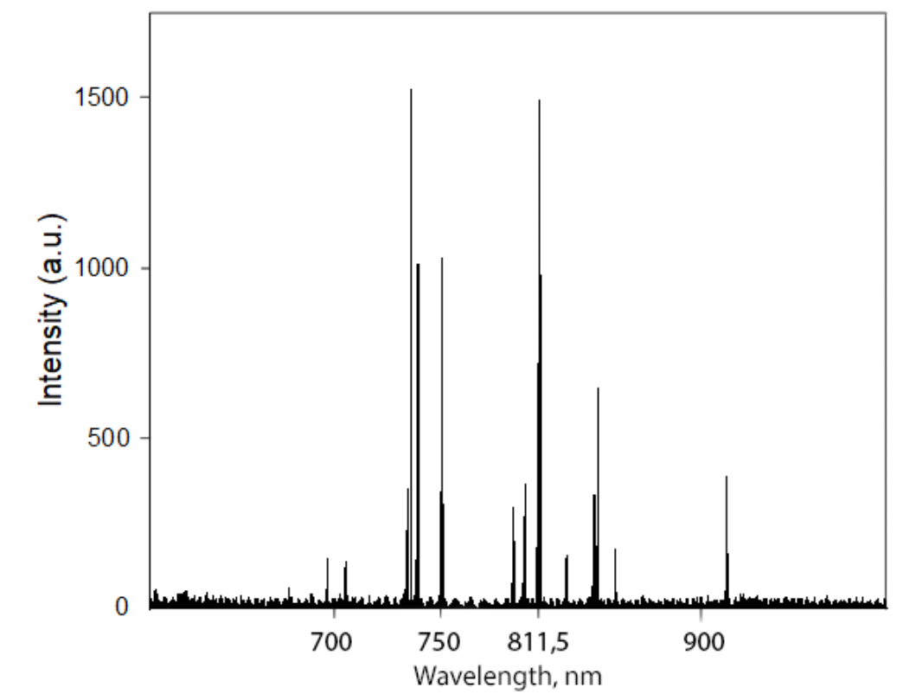 | 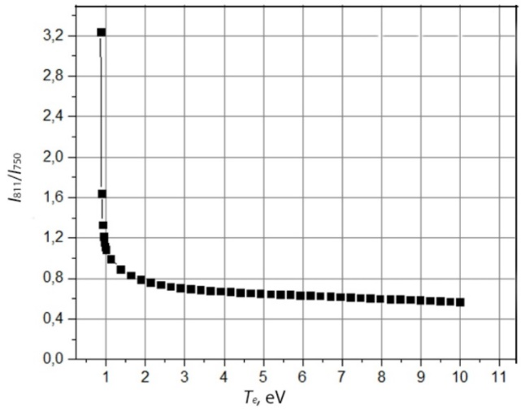
Figure 1. The Argon spectra for P=120W, l=8.5mm | Figure 2. The intensity ration dependence of T_{e}

The results of both the probe and OES measurements are presented in the table 2.
We can see that the probe and OES measured axial electron temperatures are in very good agreement along the z-axis. Inside the source and at the position of z=0 mm the electron temperature T_{e} is nearly constant. But after the z=0 mm point there is an electron temperature drop. This indicates that an energetic electron population exists upstream of the DL and disappears downstream. The existence of an energetic electron population leads to two different electron energy distributions between the upstream and downstream, and results in different electron population velocities, which cause a rapid change of the space potential that leads to plasma acceleration. Therefore, this may be one reason for the plasma acceleration in the magnetic nozzle.

Table 2. Measurement results
Axial position | 0mm (and inside the source) | 8.5mm | 20mm | 40mm
$$I_{811}^{exp}/I_{750}^{exp}$$ | 0.65 | 0.69 | 0.72 | 0.76
$T_{e}^{OES}$, eV | 5,2 | 3,1 | 2,6 | 2,2
$T_{e}^{probe}$, eV | 5,3 | 3,2 | 2,5 | 2,1

- Conclusions
This study has demonstrated the experimental results of measurements of the electron temperature of the wave plasma discharge along the axis by using a RFEA, Langmuire probe and OES. The results show that a double layer potential structure appears in an axial line in the vicinity of the magnetic field gradient maximum location. The ArI emission lines intensities 750 nm and 811 nm show very good consistency with an electron temperature distribution along the axis. The argon ion emission lines, which need a higher excited energy, display a fast drop upstream and then remain almost constant downstream. An energetic electron population only exists upstream, leading to different velocities of the electron population. Electron populations with different velocities result in a potential change as well as the axial distribution of metastable atoms. The axial distribution of the electron temperature shows that the DL represents a process in which the effective enthalpy converts into potential energy.

Acknowledgments
This research was funded by the Russian Foundation for Basic Research (No. 18-29-21039) and has been performed at “Beam-M” facility of Bauman Moscow State Technical University.

References
- Shumeiko A I and Telekh V D 2019 AIP Conf. Proc. 2171(1) 170019
- Dukhopel’nikov D V, Vorob’ev E V, Ivakhnenko S G, et al. 2016 J. of Surface Investigation: X-ray, Synchrotron and Neutron Techniques 10(1) 10-14
- Shumeiko A I and Telekh V D 2019 J. of Phys.: Conf. Series 1393(1) 012027
- Kuzenov V V, Ryzhkov S V, Frolko P A 2017 J. of Phys.: Conf. Series 830 012049
- Furukawa T, Takizawa K, Kuwahara D and Shinohara S 2017 AIP Advances 7(11) 115204
- Batishchev O 2009 IEEE Trans. Plasma Sci 37 1563
- Arefiev A and Breizman B 2004 Phys. Plasmas 11 2942
- Gizzatullin A R, Zhelonkin Y O, Voznesencky E F and Gizzatullin A R 2019 J. of Phys.: Conf. Serie 1328(1) 012025
- Mewe R 1967 British J. of Appl. Phys. 18(1) 107
- Bartschat K, Zatsarinny O, Bray I, Fursa D V and Stelbovics A T 2004 J. of Phys. B: Atomic, Molecular and Optical Phys. 37(13) 2617
- Charles C and Boswell R W 2003 Appl. Phys. Letters 82(9) 1356–1358

