Proceedings
Numerical simulation of solid oxide fuel cell energy production processes †
Ivan H. Beloev ¹, Antonina A. Filimonova ², Alexander V. Pechenkin ², Azamat R. Gizzatullin ², Artem S. Vinogradov ², Iliya K. Iliev ^{3,*}
Citation: To be added by editorial staff during production.
Academic Editor: Firstname Lastname
Published: date
Copyright: © 2023 by the authors. Submitted for possible open access publication under the terms and conditions of the Creative Commons Attribution (CC BY) license (https://creativecommons.org/licenses/by/4.0/).
¹ Department of Transport, “Angel Kanchev” University of Ruse, Ruse, Bulgaria.;
² Department "Chemistry and Hydrogen Energy" Kazan State Power Engineering University Kazan, Russia; aachichirova@mail.ru, pav_0910@mail.ru, gizzatar@gmail.com, teema@list.ru
³ Department of Heat, Hydraulics and Environmental Engineering, “Angel Kanchev” University of Ruse, Ruse, Bulgaria;
* Correspondence: aachichirova@mail.ru.
† Presented at the title, place, and date.
Abstract: Due to climate concerns, most countries are looking for alternative ways to generate energy in a clean, efficient and environmentally friendly way. Currently, a practical and technically feasible solution can be obtained by a gas turbine and a solid oxide fuel cell integrating to form a hybrid system. Experimental studies of thermophysical, electrochemical and other internal processes in solid oxide fuel cells are an expensive procedure, so theoretical tools such as simulation are very important in the analysis and design of a solid oxide fuel cell stack system. In this work, a 3D model of a planar fuel cell was studied. Numerical modeling was carried out, taking into account the flow channel design, the movement of thermal air and fuel flows. A calculation of the thermodynamic parameters of a solid oxide fuel cell on hydrocarbon fuel has been carried out. In conclusion, some constructive perspectives and recommendations for future research are offered.
Keywords: solid oxide fuel; numerical simulation; fuel reforming; hydrogen

1. Introduction
Solid oxide fuel cell (SOFC) is a promising energy and resource-efficient technology [1]. However, carrying out experimental studies of SOFCs for various operating conditions is not always possible due to some technical and economic reasons. It is sometimes not possible to measure all flow characteristics such as temperature, pressure, or distribution of flow rates through a fuel cell using experimental methods. SOFCs numerical simulation reveals much more possibilities for researchers [2-4]. Accurate modeling of SOFCs is a complex task. The equations of mass, energy, charge, electron transport, and electrochemistry should be calculated simultaneously at the boundaries of liquid, solids, and porous media. This physico-electrochemical task with a large number of involved parameters can be solved using commercial software packages by numerical simulation [5, 6].
The finite difference method (FDM), the finite volume method (FVM) and the finite element method (FEM) are the main applied numerical approaches for SOFCs modeling [7]. There are many commercial CFD packages based on FVM and FEM that are used for simulation of fluid and gas flows. The ANSYS and COMSOL software systems are the most frequently presented in the scientific literature among all available programs for CFD, multiphysics, chemistry, and electrochemistry. There are fundamental differences between these software packages. For example, ANSYS is based on FVM, while COMSOL is based on FEM [8-10].
Tasks that can be solved by numerical methods include modeling of electrochemical processes, collector design, performance modeling, studying the influence of the electrode microstructure, analyzing thermal stresses, and developing new structural elements.
Based on the literature data, eight areas related to the modeling and simulation of solid oxide fuel cells can be distinguished (Table 1) [11-14].
Table 1. Current SOFCs modeling areas.
Modeling area | Simulation parameters
Simulation of specific processes | Electrochemical reaction, electrode microstructure
Alternative fuels | Special fuel processing options, typical impurities and purification systems
Reforming | Internal, external and partial preliminary preparation
Operation parameters | Influence of temperature, pressure and fuel composition
Thermal effects | Evaluation of various heat transfer phenomena in collectors, stacks and single cells
Design | Planar and tubular structures, layer thicknesses and materials
Degradation | Degradation mechanisms due to impurities and thermal cycle
System level research | Evaluation of the influence of the properties of a single cell on the entire stack

An important advantage of the SOFC is the possibility of internal conversion of hydrocarbon fuel into hydrogen. Therefore, it is possible to use methane and synthesis gas as fuel without a pre-reformer system. In the case of external fuel reforming, SOFCs can use complex hydrocarbons, biofuels, industrial and social wastes, but it is necessary to carry out purification from sulfur [15]. For example, during oil refining, a hydrogen-containing gas is formed with hydrocarbons from C1 to C7, which can be converted by steam reforming to synthesis gas and then fed to the SOFC.
The issues of improving the environmental friendliness of industrial enterprises and reducing the negative impact of gas wastes on the environment are relevant today. Therefore, the purpose of the paper is to study the possibility of the SOFC operation on various fuels and to compare the parameters of operation on hydrogen and oil refining waste.

2. Materials and Methods
Numerical simulation was carried out on a personal computer with an Intel Xeon Gold processor, 512 GB of total RAM and a 1 TB SSD for more accurate and faster mathematical calculations.
The calculations were carried out in the COMSOL Multiphysics 2021 – universal software system for finite element analysis.
The geometric 3D model is built according to the specification of the actual stack design. The model is based on a 1 kW anode-supported planar SOFC developed in China. The cell size of SOFC is 16×16 cm2, with an active area of 10×10 cm2. Flows enter/exit the stack (fuel cells) through gas inlets/outlets (manifolds). Each fuel cell module block consists of a membrane-electrode complex – cathode (positive electrode), electrolyte, anode (negative electrode), air and fuel channels, and interconnections. Thus, the electrochemical active area of a 30-element SOFC stack consists of 900 identical block modules. Due to the same geometry, a numerical simulation of one block of the SOFC cell was carried out. The dimensions and geometry of the block are presented in Table 2.
Table 2. Geometry and materials of SOFC cell block
 | Material | Dimensions (length, width, height) | Porosity | Tortuosity
Channel | steel | 100×1.4×1.4
Edge | steel | 100×1×1.6
Anode | YSZ ¹ + NiO ² | 100×34×0.56 | 0.25 | 2
Cathode | LSCF ³ + GDC ⁴ | 100×34×0.04 | 0.35 | 2
Anode current collector | steel | 100×34×1.6
Cathode current collector | steel | 100×34×1.6
Electrolyte | 8YSZ | 100×34×0.02
¹ YSZ – Yttria-stabilized zirconia
² NiO – Nickel oxideTables may have a footer.
³ LSCF – Lanthanum strontium cobalt ferrite
⁴ GDC – Gadolinium doped ceria
Input parameters and composition of the simulated gas flows are presented in Table 3. Hydrogen, methane and synthesis gas were used as fuel. The composition of the synthesis gas, which was obtained from the gas waste of oil refining by steam reforming, was modeled in the Ansys Fluent 2021 software package at a temperature of 873 K and a pressure of 10 bar on a nickel catalyst.
Table 3. Fuel cell inlet gas flow characteristics
Parameter | Hydrogen | Methane | Synthesis gas
Mass flow at the anode, kg/s | 5·10⁻⁹
Mass flow at the cathode, kg/s | 7·10⁻⁷
Inlet temperature at the SOFC, K | 1123
Mass composition of the anode input flow, % | 97 Н₂/ 3 Н2О | 40% СН₄ / 60% Н₂О | СН₄ – 21%, Н₂О – 10%, СО – 11%, Н₂ – 46%, СО₂ – 8%, N₂ – 4%
Mass composition of the cathode input flow, % | 21 О₂/ 79 N₂

A mesh with hexahedral cells was chosen for numerical calculations. The number of cells was 2.2 million. The mesh quality indicator was close to 1.
The following assumptions and simplifications were used for calculations using the numerical model:
- Atmospheric inlet pressure;
- The flows are laminar;
- For carbonaceous fuels, only steam reforming and carbon dioxide reforming are permitted;
- The operating temperature range is 700 – 1000 °C;
- The seal between structural elements is assumed to be ideal;
- No leakage effect;
- Heat loss to the environment is based on radiation only;
- Joule heating is neglected;
- The installation works in a stationary mode;
- Chemical reactions occur in one stage.
The real processes in a fuel cell are a combination of matter transfer, heat transfer, electron transfer, and electrochemistry.
Velocity and pressure in stationary hydrodynamics do not depend on time and space. Therefore, for the distribution of velocity and pressure in the cell, the momentum conservation equations (Navier-Stokes equation) were used. Diffusion of chemicals in a laminar flow was modeled according to Fick's law.
When modeling gas flows, the laws of conservation of mass, momentum, and energy of incompressible laminar flows were used. For a finite volume dV, the fundamental equations apply under stationary conditions 𝜕⁄𝜕𝑡 = 0.
The mass of all chemicals is constant, but the composition changes due to electrochemical reactions.
, | (1)
m_{i,in} – mass flow rate of chemicals, kg/m3·s
c_{i,k} – stoichiometric coefficient of the i-th component in the k-th reaction
$v_{k}$ – k-th reaction rate
Mass Conservation Equation
, | (2)
ε - porosity, $ρ$– density, kg/m3
The total consumption of substances can be calculated using the following formula:
m = mH2 + mO2 + mH2O, | (3)
where the consumption of each i-th component is calculated as follows:
, | (4)
М_{i} – molar mass.
Due to the low Reynolds number and steady state, the conservation equation can be written as:
, | (5)
where k_{g} is the permeability of the gas phase, m²; μ is the gas viscosity kg/(m·s)
The equation of substance transfer in SOFC can be written as:
, | (6)
where y_{i} is the mass fraction of the substance; D_{ef,ij} is the effective diffusion coefficient between i-th and j-th substances (m²/s); x_{j} is the mole fraction of the j-th substance. The energy conservation equation can be formulated as follows:
, | (7)
where С_{p} is the specific heat capacity, J/kg·K; k_{ef} is the thermal conductivity coefficient, W/m·K; $Q_{v}$ is the heat flow, W/m³.
To solve the charge conservation equation, the transport of electrons and ions must be taken into account. An electronic charge occurs in the electrodes and connecting elements. While ionic charge exists only in electrodes and electrolyte.
According to Ohm's law, the electronic charge balance is calculated as follows:
On the anode: $∇\left(σ_{a}∇∅_{e}\right)=-J_{a}A_{V}$
On the cathode: $∇\left(σ_{c}∇∅_{e}\right)=-J_{c}A_{V}$
According to Ohm's law, the ionic charge balance is calculated as follows:
In electrolyte: $∇\left(σ_{el}∇∅_{i}\right)=0$
On the anode: $∇\left(σ_{a}∇∅_{i}\right)=J_{a}A_{V}$
On the cathode: $∇\left(σ_{c}∇∅_{i}\right)=J_{c}A_{V}$
where ∅ is the exchange potential, i – ionic, e – electronic, el – electrolyte, V; $σ_{a}$ and $σ_{c}$ are the electrical conductivity of the anode and cathode, respectively, S/m; $J_{a}$ and $J_{c}$ are the current densities of the anode and cathode, respectively, A/m²; $A_{V}$ is the reaction area per unit volume, m²/m³.
The cell voltage can be calculated using the following equation:
V_{сell} = Е_{N} – ŋ_{ohm} – ŋ_{act} – ŋ_{con}
where Е_{N} is the Nernst voltage (open circuit voltage), V; ŋ_{ohm}, ŋ_{act}, ŋ_{con} are the ohmic, activation, concentration overvoltages, respectively.
The value of the Nernst voltage is related to the composition of the gas, operating pressure, operating temperature and is determined by the equation:
, | (8)
where T is the temperature, K; Р is the pressure, Pa; R is the gas constant, J/mol·K; F is the Faraday constant, C/mol; ∆G is the Gibbs energy, J.
The activation voltage loss is calculated using the Butler-Volmer equation:
, | (9)
where I is the current density on the electrodes, A/m²
J₀ – exchange current density, A/m²
a – charge transfer coefficient
z — number of electrons
Concentration voltage loss is determined by the equation:
, | (10)
where I_{L} is the limiting current density, A/m²
Finally, the ohmic voltage loss is described as follows:
, | (11)
where T₀, δ and γ are SOFC constant coefficients; δ and γ are the internal resistances; r is the total resistance of the SOFC.
When using synthesis gas that contains methane or carbon monoxide, a rather low electrochemical CH₄ conversion rate and a fast steam shift reaction at the SOFC operating temperature with the formation of CO/H₂ and CO₂/H₂O are noted, which almost instantly come into equilibrium. Thus, the electrochemical conversion of CO is indirectly modeled by the additional electrochemical conversion of hydrogen and includes the rate of the carbon monoxide conversion reaction.
Since the steam reforming of methane is an endothermic reaction and the electrochemical oxidation of hydrogen is an exothermic reaction, this is the main reason for the temperature gradient within the stack. The model should include the corresponding homogeneous gaseous methane steam reforming and steam shift reactions. The steam reforming reaction proceeds as a direct bulk gas reaction with a reaction rate of ϑ𝐶𝐻₄.
, | (12)
where 𝑘 is the reaction rate constant; p_{i} are the partial pressures of CH₄, H₂O, H₂, CO.
The Nernst potential in a gas mixture of equilibrium composition is equivalent for each oxidation reaction under consideration, since only the gradient matters for the partial pressure of oxygen between the electrodes.
, | (13)
As a consequence, the hydrogen oxidation reaction provides the same Nernst voltage 𝑉_{𝑁} as the oxidation of carbon monoxide in a gas mixture at equilibrium.
, | (14)

, | (15)

3. Results and discussion
The predicted current density versus voltage (J-V) for the numerical model showed acceptable accuracy with the manufacturer's data as shown in Fig. 1. However, simulations have shown different current densities at lower voltages.

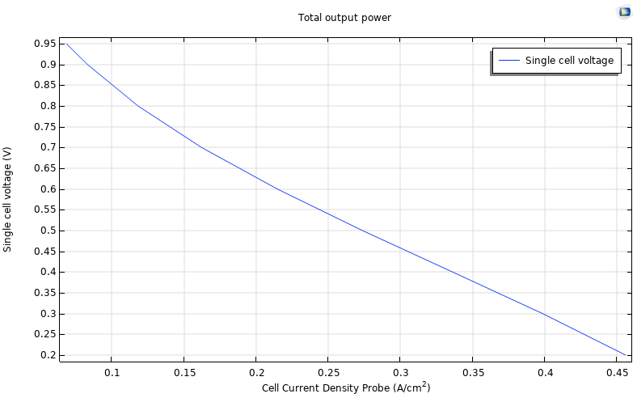 | 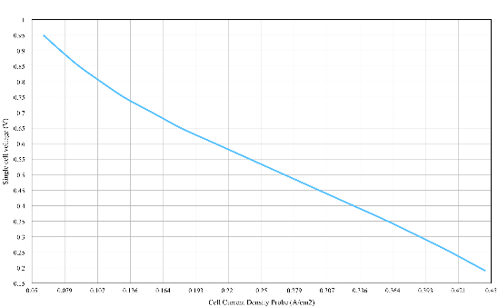
(a) | (b)
Figure 1. Volt-ampere characteristic for hydrogen fuel. (a) SOFC model data; (b) Manufacturer’s data.
Volt-ampere characteristics for methane and synthesis gas are shown in Figures 2 a, b. At the same voltage, the maximum current density is reached for hydrogen fuel (0.22 A/cm2 at 0.6V), then it decreases slightly for synthesis gas (0.2 A/cm2 at 0.6V) and the lowest current density is observed for methane (0.17 A/cm2 at 0.6V). These obtained results are consistent with the data on the net calorific value of the fuel (Table 4).

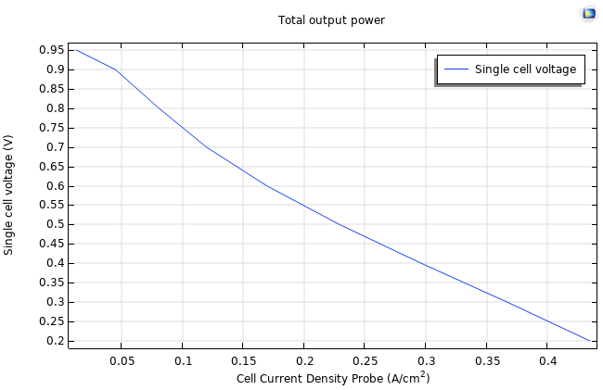 | 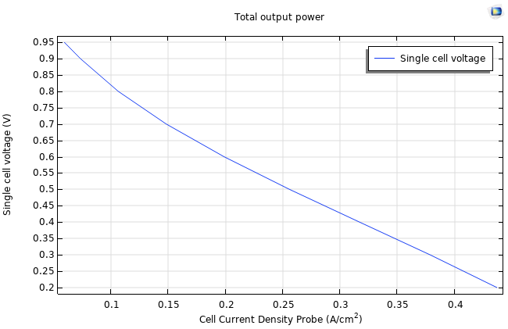
(a) | (b)
Figure 2. Volt-ampere characteristics of the SOFC (a) On methane; (b) On synthesis gas.
The distribution of chemicals along the channel is shown in Figures 3-5.

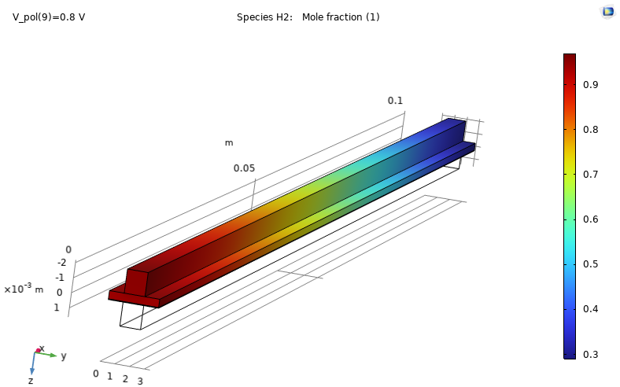 | 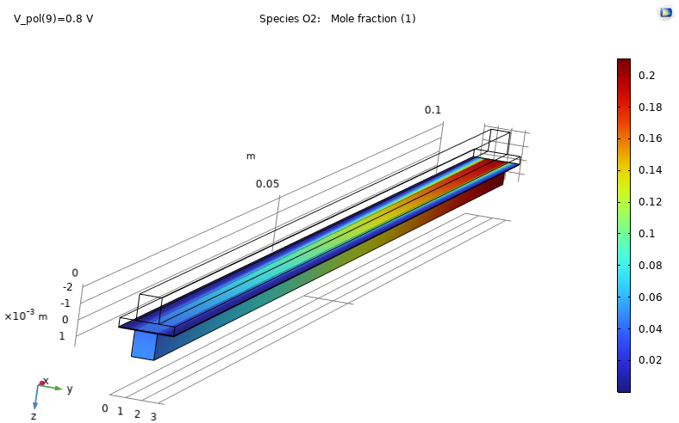 | 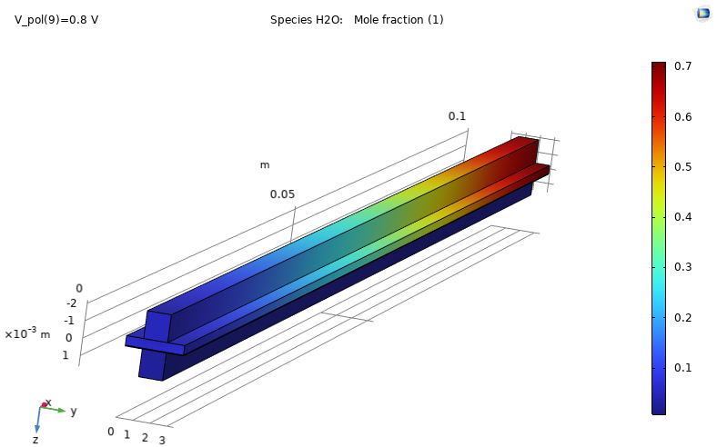
(a) | (b) | (c)
Figure 3. Distribution of (a) Hydrogen; (b) Oxygen; (c) Water through the channels when hydrogen is supplied as a fuel.
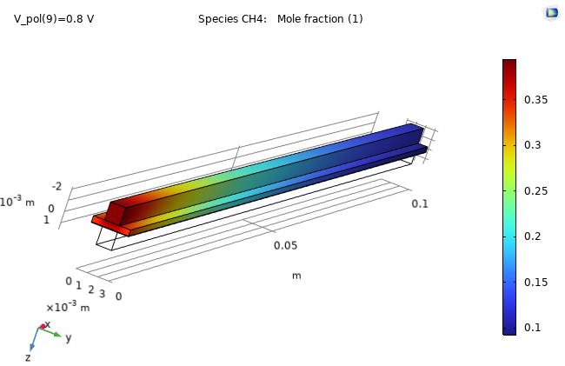 | 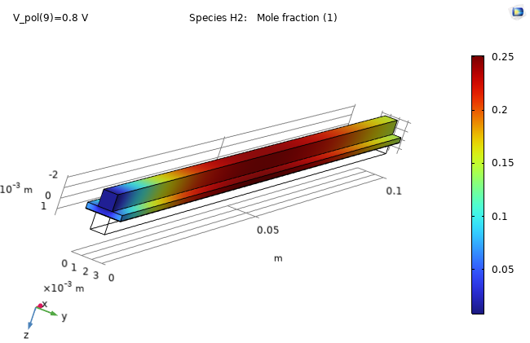 | 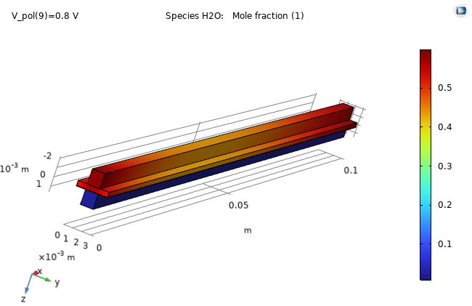
(a) | (b) | (c)
Figure 4. Distribution of (a) Methane; (b) Hydrogen; (c) Water through the channels when methane is supplied as a fuel.
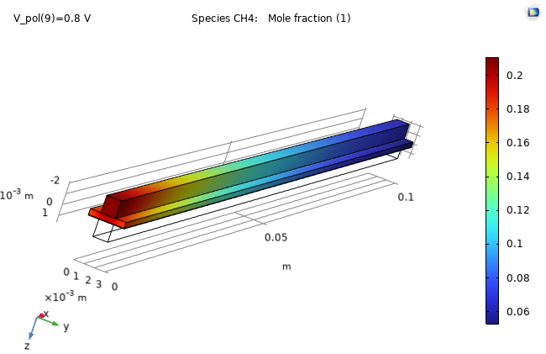 | 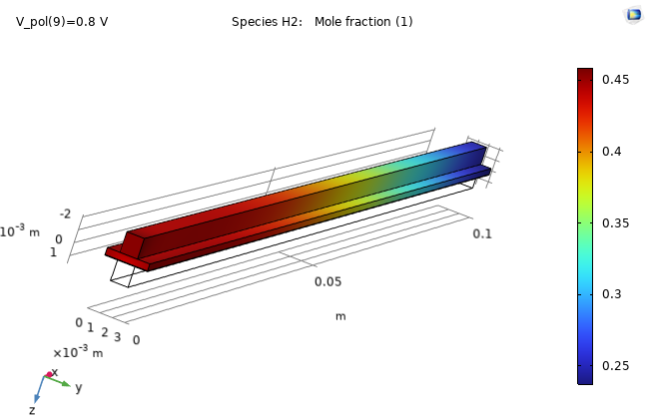 | 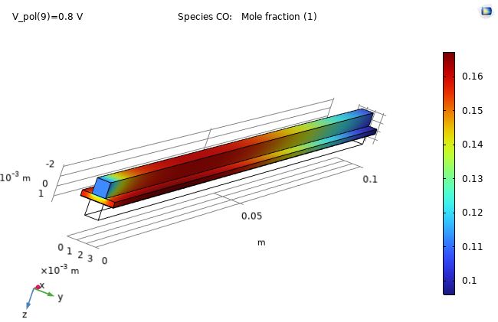
(a) | (b) | (c)
Figure 5. Gas distribution of (a) Methane; (b) Hydrogen; (c) Carbon monoxide through the channels when synthesis gas is supplied as a fuel.
When methane is supplied as a fuel, a steam reforming reaction occurs. Hydrogen is formed at the anode, which increases towards the center of the channel and then is consumed in an electrochemical reaction with oxygen (Fig. 4). Water is supplied together with methane. Therefore, there is a large amount of water at the beginning of the channel and at the end, as a product of the electrochemical reaction.
When synthesis gas is used as a fuel, the reactions of steam reforming, carbon monoxide oxidation, and the interaction of hydrogen with oxygen occur simultaneously.
Hydrogen is supplied in a sufficiently large amount in the fuel mixture, and is also formed as a result of steam reforming. Therefore, a large amount of hydrogen is observed up to the middle of the channel, then it begins to be consumed in the electrochemical reaction (Fig. 5). Carbon monoxide also enters the fuel mixture and reacts with oxygen to form carbon dioxide.
Table 4 presents the calculated parameters of the SOFC operation efficiency on various types of fuel.
Table 4. The calculated parameters of the SOFC operation efficiency on various types of fuel
 | Hydrogen | Methane | Synthesis gas
Electrical efficiency, % | 64.2 | 49.5 | 58
Fuel consumption per 1 W of power, g/hW | 0.04 | 0.052 | 0.045
Molar ratio of water and fuel | - | 1.7 | 1
Reagent utilization rate | 0.66 Н₂ | 0.71 СН₄ | 0.7 СН₄  0.375 СО  0.44 Н₂
Temperature gradient, K | 21.7 | 41.7 | 33
Thermal power, W | 25.2 | 48.4 | 39.6
Lower calorific value of fuel, MJ/kg | 140 | 50 | 76
According to the results of the study, the highest electrical efficiency can be obtained when operating SOFC on hydrogen. Synthesis gas obtained by reforming industrial waste also shows good results in terms of efficiency, fuel consumption, and reagent utilization due to its high content of hydrogen, methane and carbon monoxide.
The ratio of steam to methane is 1.7. The obtained value is within the range of acceptable values indicated in the literature (1.7-2.5), in which no carbon deposits are observed. In the case of using synthesis gas, additional water is formed in the reaction of hydrogen with oxygen, which can also be used for methane reforming.
The heat generated by the fuel cell can be used for pre-reforming or for hybridization of the cycle with other power plants. The largest amount of heat can be obtained by using methane as a fuel.

3. Conclusion
The authors present a model of the SOFC membrane-electrode module, which takes into account the influence of hydro-gas dynamics, mass transfer, the effects of electrochemical and thermal transfer in the cell structure. The mathematical model includes interconnected equations of momentum, mass, heat and charge transfer, electrochemical reaction, and reforming reactions. Model verification and validation is provided by experimental data. Numerical stability and simulation capabilities of this multiphysics model are provided by the computational grid, which consists of 2.2 million cells. The paper provides detailed information on the distribution of chemical flows, temperature, current density, etc. With the help of numerical simulation, the influence of various types of fuel on the efficiency of SOFC was studied. It is shown that fuel from petrochemical wastes has high electrical and thermal efficiency with an average consumption of reagents and high fuel utilization factor.

3. Acknowledgment
The results were obtained with the financial support of Ministry of Science and Higher Education of the Russian Federation “Study of processes in a fuel cell-gas turbine hybrid power plant” (project code: FZSW-2022-0001).

References

- Iliev I K, Filimonova A A, Chichirov A A, Chichirova N D, Pechenkin A V, Vinogradov A S, 2023 Theoretical and Experimental Studies of Combined Heat and Power Systems with SOFCs Energies 16 1898
- Hussain J, Ali R, Akhtar M N, Jaffery M H, Shakir I, Raza R, 2020 Modeling and simulation of planar SOFC to study the electrochemical properties Curr. Appl. Phys. 20 (5) p 660-672
- Andersson M, Yuan J, Sundén B, 2012 SOFC modeling considering electrochemical reactions at the active three phase boundaries Int. J. Heat Mass Transf. 55 (4) p 773-788
- Ilbas M, Kumuk B, 2019 Numerical modelling of a cathode-supported solid oxide fuel cell (SOFC) in comparison with an electrolyte-supported model J. t Energy Inst. 92 (3) p 682-692
- İlbaş M, Kümük B, 2020 Modeling and analysis of a model solid oxide fuel cell running on low calorific value coal gases, Int. J. Hydrog. Energy 45 (5) p 3577-3583
- Amedi H R, Bazooyar B, Pishvaie M R, 2015 Control of anode supported SOFCs (solid oxide fuel cells): Part I. mathematical modeling and state estimation within one cell Energy 90 (1) p 605-621
- Yang B, Wang J, Zhang M, Shu H, Yu T, Zhang X, Yao W, Sun L, 2020 A state-of-the-art survey of solid oxide fuel cell parameter identification: Modelling, methodology, and perspectives Energy Convers. Manag. 213 112856
- Horr S, Mohcene H, Bouguettaia H, Moussa H B, 2021 Performance analysis of AS-SOFC fuel cell combining single and sinusoidal flow field: numerical study Renew. Energy Environ. Sustain. 6 (18)
- Błesznowski M, Sikora M, Kupecki J, Makowski Ł, Orciuch W, 2022 Mathematical approaches to modelling the mass transfer process in solid oxide fuel cell anode Energy 239 (A) 121878
- Pongratz G, Subotić V, Hochenauer C, Scharler R, Anca-Couce A, 2022 Solid oxide fuel cell operation with biomass gasification product gases: Performance- and carbon deposition risk evaluation via a CFD modelling approach Energy 244 (B) 123085
- Kalra P, Garg R K, Kumar A, 2020 Parametric sensitivity analysis for a natural gas fueled high temperature tubular solid oxide fuel cell Heliyon 6 (7) e04450
- Kim D H, Bae Y, Lee S, Son Ji-W, Shim J H, Hong J, 2020 Thermal analysis of a 1-kW hydrogen-fueled solid oxide fuel cell stack by three-dimensional numerical simulation Energy Conversi. Manag. 222 113213
- Li Pei-W, Chyu M K, 2003 Simulation of the chemical/electrochemical reactions and heat/mass transfer for a tubular SOFC in a stack, J. Power Sources 124 (2) p 487-498
- Filimonova A A, Chichirov A A, Chichirova N D, Pechenkin A V, 2022 Overview of design diagrams for solid oxide fuel cell and gas turbine hybrid systems for combined heat and power generation. J. Sib. Fed. Univ. Eng. & Technol. 15(7) p 812–834
Disclaimer/Publisher’s Note: The statements, opinions and data contained in all publications are solely those of the individual author(s) and contributor(s) and not of MDPI and/or the editor(s). MDPI and/or the editor(s) disclaim responsibility for any injury to people or property resulting from any ideas, methods, instructions or products referred to in the content.

