Evaluation of approaches to managing the technical condition of electric power facilitiess

Yuliya Zatsarinnaya¹, Guzel Valeeva²  ^{1,2}Department of Power stations named after V.K. Shibanov  ^{1,2}Kazan State Power Engineering University  ^{1,2}Kazan, Russian Federation  waysubbota@gmail.com¹, guzel-valeeva-99@mail.ru² | Marina Shustrova3  ³Department of Automated systems of iIndustrial enterprises  ³Kazan National Research Technological University Kazan, Russia  shu.ma@bk.ru³

Abstract – The issue of repair of power equipment is relevant, because the good technical condition of the equipment provides a reliable and uninterrupted supply of consumers. Also the cost of maintaining the technical condition is less than the cost of purchasing a new one. The article presents approaches to managing the technical condition of power equipment, features of approaches and their properties. Also the analysis of expediency of applying approaches to different groups of equipment, advantages and disadvantages of each approach is made.
Key words: equipment repair, equipment repair program, power equipment, scheduled preventive repair.

Introduction
Operation of energy industry facilities is impossible without organizing the power equipment repairing processes. Most energy companies are under tight conditions. On the one hand, there is a need to ensure high-quality and uninterrupted power supply. Оn the other hand, the goal of any enterprise is a profit, the amount of which also depends on the cost of the equipment repairing [1].
Ensuring both requirements are largely interrelated. Qualitative and uninterrupted power supply can be provided only with timely and highly efficient repair of power generation, transmission and distribution facilities [2].
The objects involved in the process and directly related to production and distribution are part of the production complex of the energy sector (hereinafter referred to PCES). These include based process equipment of power facilities (e.g. high power generators, high voltage transformers, turbines, boilers, etc.).
Maintaining the technical condition of the main process equipment is quite expensive. Without creating the necessary conditions, the equipment can wear out in a short period, and require more capital costs: these are the costs of acquiring and maintaining equipment. The main necessary conditions at the facilities of operation of the main process equipment can be described as the proper condition of the buildings and structures in which the PCES is contained, the availability of personnel with the proper qualifications in the repair team for servicing the PCES. In this regard, it is necessary to organize the process of maintaining the technical condition of the facilities that ensure the operation of the PCES. These objects are called the process complex of the energy sector (hereinafter – TCES). These include auxiliary equipment (pumps, heaters, etc.), buildings and structures (in which the PCEC facilities are located), transport necessary for servicing the PCES, etc. [3].
Fig. 1 shows the structure of the Technical Power System in terms of asset type.
The following tasks are required to ensure the operation of PCES and TCES.
- Provision of serviceable condition of PCES and TCES facilities;
- Maintenance of serviceable condition of PCES and TCES facilities;
- Creation of an organized system to ensure the serviceability of the PCES and TCES;
- Provision of information and methodological support of the system;
- Generation of requirements for serviceability;
- Experience analysis, correcting actions to ensure the best outcome.
The study is based on the selection of the most optimal ways to ensure the serviceable state of PCES and TCES.
Managing the technical condition of the electric power complex assets is the most rational approach from the investments point of view [4].
This work allows you to:
- To determine the most optimal approach to the management of the technical condition of the equipment;
- In accordance with the chosen approach to determine the strategy of impact on the equipment;
- Determine the risks of equipment failure based on the value of the probability of failure.

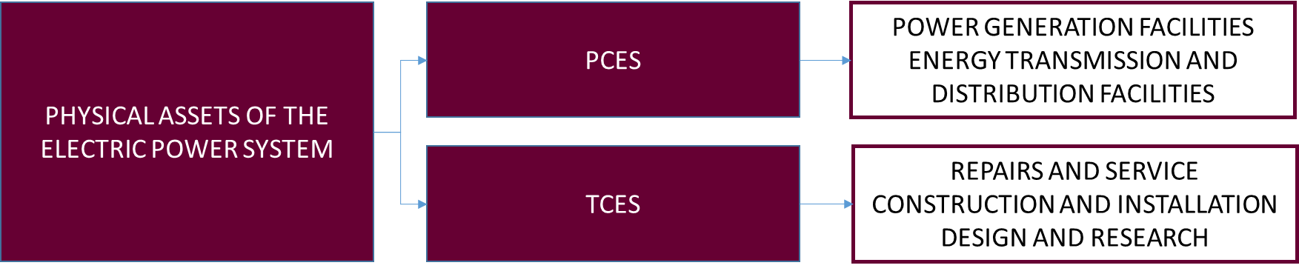
- Structure of electric power system in section of asset type

Approaches to management of electric power facilities technical condition
Table I shows the approaches to control the technical condition of the electric power complex facilities.
- Approaches to management of electric power facilities technical condition
№ | Approach name | Description | Key Attributes
1 | Until-failure operation | The impact on the equipment will be realized only after it reaches a critical (inoperable) state | Failure of equipment
2 | Planned maintenance by standard | The impact is carried out on the basis of the plan, which is drawn up on the basis of repair standards | Equipment development rate for the period  Period of equipment operation
3 | Scheduled maintenance by condition | Impact is based on equipment condition parameters | Equipment Health Index Value  Equipment failure probability value

Оperation until failure
Operation until failure is the first strategy in the history of equipment repair. This approach does not require the organization of repair programs. It is the easiest approach to repairing equipment. Within the framework of the approach, repair actions are carried out when the equipment reaches a critical state, which is characterized by the inability of the equipment to perform the specified functions (loss of operability) [5].
The key advantages of this approach are:
- no labor costs for planning equipment repair;
- the duration of the overhaul period is the longest, and it can correspond to the life of the equipment;
- the costs of medium and maintenance repairs are completely excluded;
- the need for maintenance teams is minimized.
However, this approach has several disadvantages:
- significant costs for the aftermath of accidents resulting from sudden equipment failure,
- significant costs for technical re-equipment and reconstruction of failed equipment.
As a result, the operation of the electric power plant requires a large number of operating costs at small values of operating costs (equipment maintenance and maintenance costs).
Fig.2 shows the diagram of equipment technical condition changes during operation before failure.
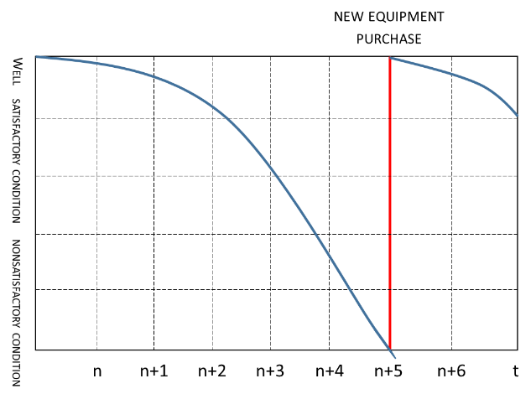
- Diagram of changes in equipment technical condition during operation before failure

Maintenance according Standard
Standards can be defined for the equipment. According to these standards, an impact should be carried out to improve the technical condition of the equipment. On the basis of these standards the frequency of maintenance, maintenance, average repair and capital repairs is defined [6].
Planned preventive maintenance according to the standard allows carrying out preventive actions in order to prevent the occurrence of inoperable condition of the equipment. The advantage of routine maintenance according to the standard is the extension of the operable condition of the equipment due to preventive effects.
The main disadvantages in this case are the following:
- increased cost of maintenance and repair;
- defects.
The increase in costs is related to the costs of preparing and carrying out technical impacts on the equipment due to the date of repair set according to the standard, and not according to the actual technical condition. In addition, it is difficult to take into account the occurrence of unpredictable defects occurring on the equipment in the conditions of carrying out impacts according to the standard [7].
Fig. 3 shows changes in equipment technical condition during planned preventive maintenance according to the standard.
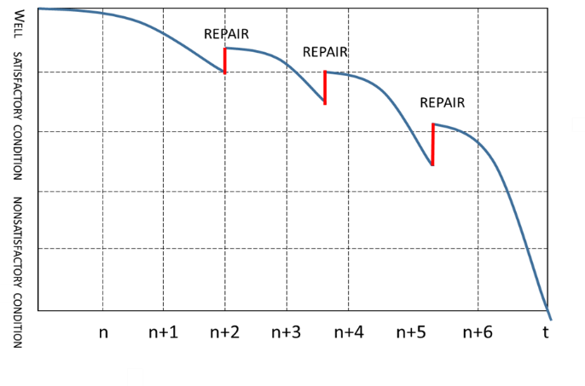
- Diagram of change of equipment technical condition during planned preventive maintenance according to the standard

Scheduled maintenance by condition
Scheduled preventive maintenance as per condition is carried out on the basis of the actual technical condition of the equipment. The actual technical condition of the equipment is determined based on the values of the technical condition index and the probability of equipment failure [8].
Scheduled maintenance as per condition is performed according to the following stages:
- Determination of the current technical condition of the equipment (calculation of values of the technical condition index and probability of equipment failure at the moment);
- Comparison of calculated results value with standard values of technical condition index and probability of equipment failure, determination of deviations criticality;
- Analysis of changes in values of technical condition index and failure probability with calculated values of previous calculation periods;
- Formation of repair program based on criticality of deviation from the standard value; selection of impact type;
- Repair costs calculation;
- Repair;
- Analysis of carried out impacts results (calculation of technical condition index and a failure probability after repair) [9], [10].
Currently, the calculation of the technical condition index and failure probability for the main process equipment is methodologically implemented.
Calculation is performed for the equipment and its functional units [11], [12].
EСI_{у}=100×∑_{i}K_{i}×EPG_{i}/4 
where EСI_{у} (Equipment Сondition Index) is an equipment functional unit technical condition index;
K_{i} is the weight of the group of parameters reflecting the technical condition of the equipment;
EPG_{i} (evaluation of parameter group) is the score of a group of parameters (the deviation of the actual values of the group of parameters from the normative values is determined).
In order to create the program of scheduled preventive repair by condition, it is necessary to calculate the forecast of the change in the technical condition index [13] – [15].
у(t)=(1–|tanα_{fу}|×t)×EСIу/100 (2)
where t – prediction time, years;
tanα_{fу} – tangent of tilt angle of change of technical condition index over the past period.
Based on the forecast data of the change in the technical condition index, it becomes possible to calculate the probability of equipment failure.
p_{f} (t)=(1–у(t))×k (3)
where у(t) is the function of predicting a change in the technical condition index;
p_{f} (t) is a probability of equipment failure;
k is a coefficient calculated based on the value of the technical condition index for the previous and current period.
This maintenance approach eliminates the extra cost of repairing the equipment, since the impact is carried out only on equipment requiring technical impact.
Fig. 4 shows the diagram of change of equipment technical condition during scheduled preventive maintenance as per condition.
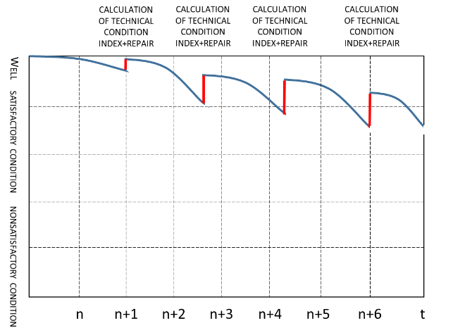
- Schedule of change of equipment technical condition during scheduled preventive maintenance by condition

Analysis of technical management approaches
Each given approach of equipment technical state control is an evolutionary stage of technical state control system development. But at present, none of the approaches has lost their relevance.
Based on the above data, it is necessary to analyze the feasibility of applying each approach to technical condition management for different types of equipment. The analysis data are shown in Table II. The strategies for managing the state of the equipment are shown in the Fig.5.
- Assessment of technical state management approaches
№ | Approach name | Method of technical condition change | Advantages | Disadvantages | Method of works organization | The approach is appropriate for the following equipment groups | Rationale for the approach
1 | Until -failure operation | Equipment replacement with new ones (technical re-equipment and reconstruction) [16] | Low training and maintenance costs | Equipment outages during repair, low reliability, unforeseen costs | Station employees | Small-sized equipment of stations not involved in the main process (TCES facilities - gate valves, small-sized pumps of non-essential consumers, some separate spare parts of equipment, etc.) | Lower operational maintenance costs (replacement costs significantly lower than maintenance monitoring costs)
2 | Planned maintenance by standard | Impact on equipment within the timeframe specified in the regulatory documentation (industry standards of equipment production, manufacturer's recommendations, etc.) | Ensure reliability, reduce downtime | Excessive or insufficient maintenance of equipment, maintenance, training, provision of repair personnel | Station employees  Employees of contracting organizations | Overall equipment that ensures the functioning of the main production process, but does not participate in the generation of a useful product - electricity (TCES - circulation, feed, booster pumps, deaerators, blast fans, smoke pumps, etc.) | Ensuring reliability of equipment operation
3 | Scheduled maintenance by condition | Impact on equipment by values of design data of technical condition index, probability of equipment failure [17] | Ensure high reliability, minimize equipment downtime, eliminate unnecessary or inadequate maintenance | Costs of status monitoring and calculation of technical status index values and failure probability | Employees of contracting organizations  Maintenance of equipment manufacturers | The main equipment involved in the process of obtaining a useful product - electrical energy (PCES - generators, transformers, boilers, turbines, etc.). This group is the most critical because if its elements fail, the main process can stop and cause an emergency. | Ensure equipment reliability with cost minimization and selection of optimal impacts

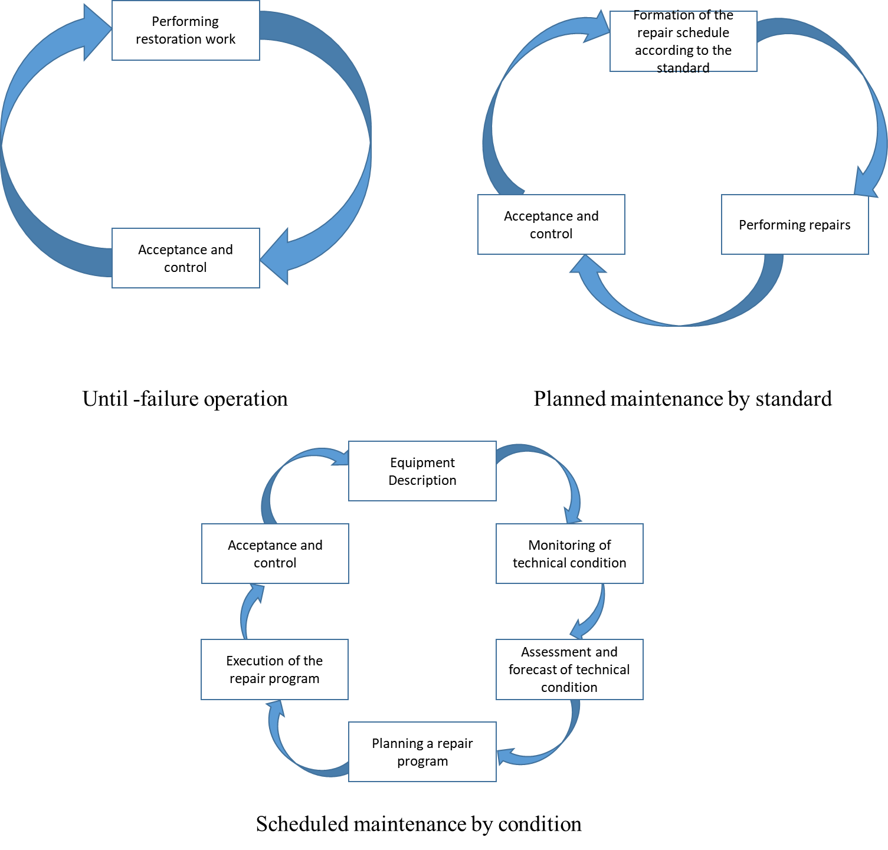
- Hardware health management strategies

Results
The paper describes and analyzes approaches to managing the technical condition of power equipment. In view of the complexity of calculations and analysis of the need to perform repairs when implementing the planned preventive maintenance approach, its application for the facilities of the PCES is the most appropriate. The PCES ensures the functioning of the energy sector as a whole, is responsible for the creation and transfer of a useful product – energy. In this regard, there is a need to ensure a high level of reliability of this equipment, insofar as the supply of consumers, such as industrial enterprises, hospitals, transport, etc., depends on the functions performed by the PCES [14].
At the same time, the approach of planned preventive maintenance is labor-intensive, and requires a specialized software package, which can be expensive. But with regard to the risks of equipment failure and the consequences of equipment failure, the approach of preventive maintenance according to the condition, with the use of which it is possible to determine the time of equipment failure, is a relatively insignificant capital investment.
The approach of scheduled preventive maintenance according to the standard can also be applied for the PCSE. But this approach reflects statistical data and does not make it possible to predict the risk of failure of specific equipment, therefore it provides less reliability.
For TCES, the use of a planned preventive maintenance approach is not advisable, since TCES facilities are providing the activities of the PCES, and are not responsible for the transfer of a useful product. The most appropriate approach is to use the planned preventive maintenance approach according to the standard, since this approach is able to provide the required level of reliability with minor labor costs and investments. If the TCES object is the least important from the point of view of the impact on the PCES, the approach of operation to failure is allowed (in this case, the replacement of the object may be cheaper than its repair) [15].

Conclusion
The study shows that the approaches for most profitable and efficient management of the technical condition of different asset types (PCES and TCES) differ significantly. The purpose of technical state management determining approaches is to ensure the reliability of the operation of electric power facilities, ensuring the production process continuity. Technical state control methods for each group of equipment allow to select the most optimal effects, which make it possible to ensure the reliability of the electric power system with the minimum required number of resources.

References
- A. Kosyakov, U. Sweet, S. Seymour, S. Beamer, M., "System engineering. Principles and Practice"(Sistemnaya inzheneriya. Principy` i praktika), DMK Press, 2017 (in Russ)
- GOST R 27.606-2013. Reliability in technology. Reliability management. Maintenance focused on reliability (Nadezhnost` v texnologii. Upravlenie nadezhnost`yu. Texnicheskoe obsluzhivanie, orientirovannoe na nadezhnost`), FGUP "VNIINMASh", 2013 (in Russ)
- V.N. Galushko, S.G.Dodole, "Reliability of electrical installations, power systems and radio-electronic means"(Nadezhnost` e`lektroustanovok, e`nergosistem i radioe`lektronny`x sredstv), MTKRB UO “BGUT”,Gomel, 2018 (in Russ)
- A. Nazarychev, A. Tadzhibaev, Y. Solovyev, "The Inspection of the Technical State of Critical Infrastructure Facilities" (Proverka texnicheskogo sostoyaniya ob ektov kriticheskoj infrastruktury`) International Conference on Problems of Critical Infrastructures, Proceedings. Irkutsk: Energy Systems Institute, 2015 (in Russ)
- A. Nazarychev, M. Huhtinen, "Learning from Differences in Energy Sector" (Izvlekaya uroki iz razlichij v e`nergeticheskom sektore) International Seminar, Proceedings St. Petersburg, Kotka: PEIPK, KYAMK, 2016. (in Russ)
- Y. Solovyev, A. Nazarythev, A. Tadzhibaev, "Details on technical condition assessment of overhead covered conductors under extreme climatic impacts" (Podrobnaya informaciya ob ocenke texnicheskogo sostoyaniya vozdushny`x pokry`ty`x provodnikov pri e`kstremal`ny`x klimaticheskix vozdejstviyax) Proceedings of 2014 Electric Power Quality and Supply Reliability, Rakvere, Estonia, June 2014.(in Russ)
- I.N. Sulynenkov, A.N. Nazarychev, A.I. Tadzhibayev, "Reliability Model of High-Voltage Circuit Breakers With Taking Into Account Breaker Failure Protection" ( Model` nadezhnosti vy`sokovol`tny`x avtomaticheskix vy`klyuchatelej S uchetom zashhity` ot otkaza vy`klyuchatelya) Scientific – Industrial Journal Electroenergetics, Electrotechnics, Electromechanics + Control. Vol. 4. 2013. (in Russ)
- A.N. Nazarychev, A.I. Tajibaev, "Management of the technical condition of electrical installations of active-adaptive energy enterprises" (Upravlenie texnicheskim sostoyaniem e`lektroustanovok aktivno-adaptivny`x e`nergeticheskix predpriyatij). St. Petersburg: PEIPK, 2011. (in Russ)
- A.N. Nazarychev, "Basic principles of the system of maintenance and repair of electrical equipment according to technical condition" (Osnovny`e principy` sistemy` texnicheskogo obsluzhivaniya i remonta e`lektrooborudovaniya v sootvetstvii s texnicheskim sostoyaniem) Reliability of liberalized energy systems. 2004. (in Russ)
- SO 34.20.608-2003 (RD 153-34.0-20.608-2003) "The project of works for the repair of power equipment of power plants. Requirements for composition, content and design. Methodical instructions" (Proekt rabot po remontu e`nergeticheskogo oborudovaniya e`lektrostancij. Trebovaniya k sostavu, soderzhaniyu i dizajnu. Metodicheskie ukazaniya.). 2003.(in Russ)
- Ministry of Energy of the Russian Federation dated October 25, 2017 Order No. 1013 "Rules for the organization of maintenance and repair of electric power facilities" (Pravila organizacii texnicheskogo obsluzhivaniya i remonta ob``ektov e`lektroe`nergetiki).2017. (in Russ)
- Ministry of Energy of the Russian Federation, Order No. 676 dated 26.07.2017 "Methodology for assessing the technical condition of the main technological equipment and power transmission lines of electric stations and electric networks" (Metodika ocenki texnicheskogo sostoyaniya osnovnogo texnologicheskogo oborudovaniya i linij e`lektroperedachi e`lektricheskix stancij i e`lektricheskix setej).2017. (in Russ)
- Ministry of Energy of the Russian Federation, Order No. 123 dated February 19, 2019 "Methodological guidelines for calculating the probability of failure of a functional node and a unit of basic technological equipment and assessing the consequences of such a failure" (Metodicheskie ukazaniya po raschetu veroyatnosti otkaza funkcional`nogo uzla i bloka osnovnogo texnologicheskogo oborudovaniya i ocenke posledstvij takogo otkaza).2019. (in Russ)
- Zatsarinnaya, J.N., Amirov, D.I., Zemskova, L.V. Analysis of the environmental factors influence on the efficiency of photovoltaic systems IOP Conf. Ser. Mater. Sci. Eng.,vol. 552, no. 1, p. 012033, 2019
- Khalyasmaa, A.I., Eroshenko, S.A., Shatunova, D.V., Larionova, A.A., Egorov, A.O. Digital twin technology as an instrument for increasing electrical equipment reliability IOP Conf. Ser. Mater. Sci. Eng., vol. 836, no. 1, p. 012005, 2020
- E.Y. Balzamova, D.S. Balzamov, V.V. Bronskaya, O.S. Kharitonova, Modernization of the scheme for the delivery of thermal power from the state district power station, IOP Conf. Ser. Mater. Sci. Eng.,vol. 734, no. 1, p. 012194, 2020
- Dmitriev A. V., Madyshev I. N., Kharkov V. V., Dmitrieva O. S., Zinurov V. E., Experimental investigation of fill pack impact on thermal-hydraulic performance of evaporative cooling tower / Thermal Science and Engineering Progress. vol. 22, p. 100835, 2021
- Zatsarinnaya, J.N., Staroverova, N.A., Logacheva, A.G. Simulation of pump performance control schemes with the use of the virtual model of the process MATEC Web of Conferences, vol. 129, p. 06025, 2017

