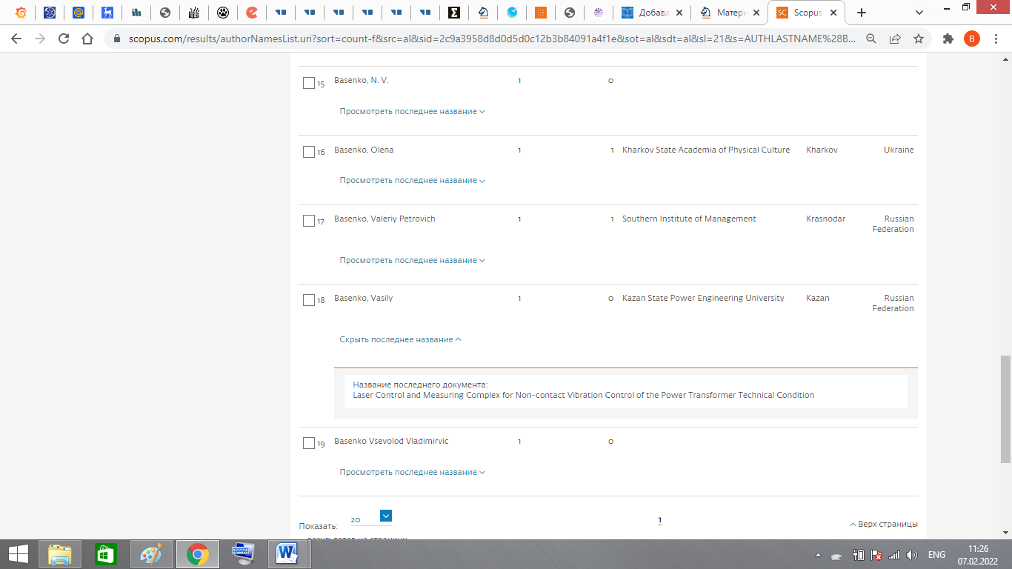
https://link.springer.com/book/10.1007/978-3-030-86047-9?page=1#toc

