УДК 621.315.145

**MONITORING THE METEOROLOGICAL DISASTERS OF POWER TRANSMISSION LINES IN CHINA'S POWER GRID**

Zakirov D.F.

KSPEU, Kazan, Russian Federation

qwerty2014dinar@gmail.com

Scient. leader associate professor Mulyukov I.M.

The thesis addresses the problem of monitoring meteorological disasters of electricity systems. The foreign experience of using sensing systems for monitoring meteorological disasters using the example of China 's power grid was analyzed.

**Keywords:** monitoring, remote sensing, power transmission lines, meteorological disasters, China.

In recent years, with the increase in the height of the supports, the class of voltage, the transmission capacity, as well as the total number of power transmission lines, there has been an increasing tendency to increase the vulnerability of the power lines to natural disasters. China is one of the countries with the most frequent natural disasters, among which meteorological disasters, including rains, floods, typhoons, ice and hurricanes, are the most frequent and seriously affecting the safe and stable functioning of China 's electricity network. In addition, many of China 's wide-area and long-line power lines pass through mountainous and unpaved areas, making it difficult to inspect and monitor the lines, thereby increasing the associated costs of these activities. In the event of the occurrence and development of natural disasters, the rapid identification of their occurrence through the use of natural disaster monitoring technology, as well as the correct and effective determination of the solution to their consequences, is the most economical and effective methodology for reducing energy losses.

In the field of disaster prevention and reduction, remote sensing technology is the main method of obtaining the information data needed for a geographic information system. Analysis of remote sensing data can reveal information on new changes that occurred during natural disasters and can also predict the possibility of their re-emergence.

However, in China, the overall use of space-based information technology for disaster management is low. Information on monitoring meteorological disasters in electricity grids comes mainly from information provided by the Meteorological Department and online monitoring devices for electricity grids. But the locations of Meteorological Department stations are widely dispersed, and there are few such sites near important power lines, so that the situation on a particular site will not meet the requirements of the energy industry. Although the energy industry exchanges information with local meteorological agencies, due to spatial differences, the need for online monitoring cannot be met. In addition, online weather monitoring devices cannot operate normally in emergency situations, and monitoring information cannot be provided over a vast area. In order to ensure the reliable operation of power grids, meteorological disasters in vast areas can be monitored by a remote sensing satellite.

The largest impact on China 's power grid was the icy rains and snowfalls that occurred in early 2008. This natural disaster caused damage to the power grid in a large area of southern China. The lines, which were destroyed and separated, were located mostly in high mountains and steep hills and had large intersections. In this disaster, the main reason for the failure of the support and the breaking of the lines on the large area of the electric grid was that the thickness of the icing was clearly greater than is permissible in the design standard. As a result, the support was deformed, collapsed and disconnected, causing a "domino effect" and causing several other neighboring supports to collapse. In this disaster, due to a lack of necessary monitoring techniques, performance was reduced and the workload for urgent repairs and line patrols became too large as line repair personnel quickly tired during the disaster period.

Information on the ice and snow cover of the corridors of power transmission lines and roads for emergency repairs was obtained by remote sensing, and the safety of power transmission lines was assessed comprehensively according to the state of support and online monitoring of important objects, as shown in Figures 1 and 2 [1,2].



Fig. 1. A picture of a snowstorm taken by a satellite HJ-1.

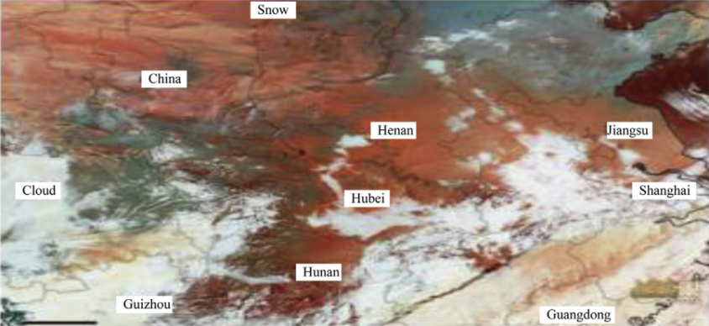

Fig. 2. A picture of a snowstorm taken by a satellite GeoEye.

Fig. 2 is formed in the infrared and visible range, thus the red (orange) region is snowfall, the white region is a layer of clouds. Green zone - land without snow or bare land.

Combined with satellite remote sensing data, the technology for monitoring meteorological disasters in power transmission line corridors includes four monitoring systems:

1. Meteorological and medium resolution satellites used for macroscopic dynamic monitoring;
2. Radar satellite used for online monitoring of natural disasters;
3. High-resolution optical satellite for high-precision disaster monitoring and damage assessment;
4. Online power line monitoring system used for fixed point online monitoring.

By combining the monitoring information collected through the above-mentioned methods, it is possible to draw up standard graphs of the meteorological separation of the power transmission line and to accurately describe the changes in the meteorological state of the corridor of the power transmission lines and the disaster.

**Sources**

1. Guo L.P. A new instrument for line insulator pollution monitoring // Central China Electric Power. 1991. С. 58-63.

2. Hu Yi. Study on analysis of the windage yaw tripping of 500 kV transmission line // High Voltage Eng. 2004. С. 9-10.